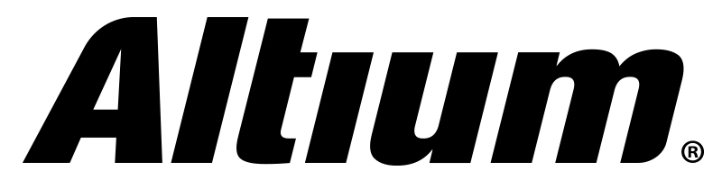

Logo available: info@prismapr.com

Press Release 10/2016

Altium Announces the Acquisition of Leading Netherlands-Based Reseller Transfer BV

San Diego, Calif. – September 15, 2016 — Altium has announced the completed acquisition of Transfer BV, a long-time and leading reseller of Altium. Transfer BV is based in the Netherlands covering the regions of Belgium, Netherlands and Luxembourg. Altium will leverage the strong capability of Transfer BV with Altium’s unique direct transactional sales model to drive future growth in Northern Europe.

Altium’s CFO, Mr Joe Bedewi welcomed the acquisition of Transfer BV, commenting “We are extending our direct reach into Northern Europe to sell directly in the Netherlands, Belgium and Luxembourg. Altium is pleased to have the highly capable and strongly motivated Transfer BV team join our direct sales force to lead our sales in Northern Europe. Transfer BV will implement Altium’s successful direct transactional sales model that has proven success in the Americas and the DACH region of Europe (Germany, Austria and Switzerland).”

Altium’s acquisition of Transfer BV involved consideration including a combination of cash and an earn-out structure, based on sales performance for the next three years.

“This is an exciting development for us” said Transfer BV’s CEO, Mr Peter de Ruiter. “Our vision for the PCB industry has always been aligned with Altium and we look forward to driving sales growth strongly in Northern Europe and putting Altium’s leading-edge PCB design tools into the hands of engineers.”

As Altium furthers its multi-product strategy and expands its reach into the higher-end of the PCB market, the company will be seeking to sell direct in key markets in Europe.

Contacts:

Waldemar Stein
Altium Europe GmbH
+49 721 8244 110
waldemar.stein@altium.com

Gabriele Amelunxen
PRismaPR
+49 8106 247 233
info@prismapr.com

Monika Cunnington
PRismaPR (UK, Scandinavia & Benelux)
+44 20 8133 6148
monika@prismapr.com
www.prismapr.com

About Transfer BV
Transfer BV has been established in Benelux since 1988 to provide Electronic Design Automation (EDA) training, electronics design software and development services. Transfer BV delivers knowledge and tools with which oitsur customers can keep controlling the increasing complexity of the electronics development process.
Also for companies that develop EDA tools Transfer BV is known as the EDA distributor that has excellent knowledge and know-how.

About Altium
Altium Limited (ASX: ALU) is a multinational software corporation headquartered in San Diego, California, that focuses on electronics design systems for 3D PCB design and embedded system development. Altium products are found everywhere from world leading electronic design teams to the grassroots electronic design community.

With a unique range of technologies Altium helps organisations and design communities to innovate, collaborate and create connected products while remaining on-time and on-budget. Products provided are Altium®, Altium Designer®, Altium Vault®, Autotrax®, Camtastic®, CircuitMaker®, CircuitStudio®, Codemaker™, Common Parts Library™, DXP™, Easytrax®, NanoBoard®, Octopart®, PCBWORKS®, P-CAD®, Protel®, Ciiva®, PDN Analyzer™, SmartParts™, ActiveRoute™, Draftsman®, Situs® and the TASKING® range of embedded software compilers.

Founded in 1985, Altium has offices worldwide, with US locations in San Diego, Boston and New York City, European locations in Karlsruhe, Amersfoort, Kiev and Zug and Asia-Pacific locations in Shanghai, Tokyo and Sydney. For more information, visit www.altium.com. You can also follow and engage with Altium via Facebook, Twitter and YouTube.

