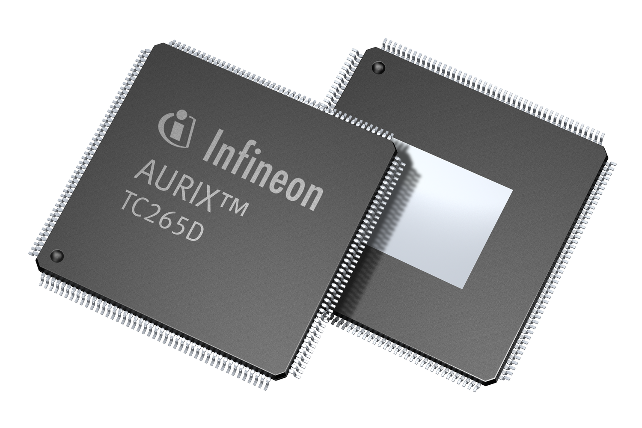
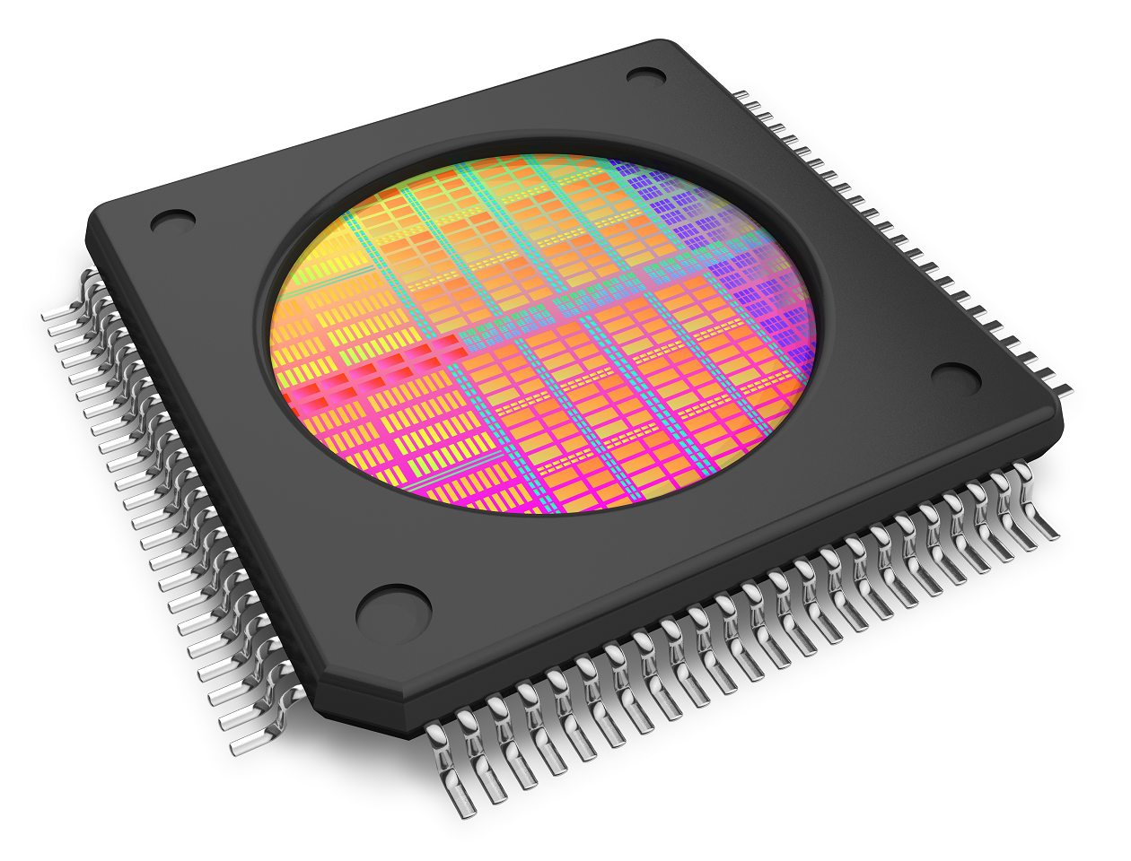

Pictures available: info@prismapr.com

Press Release 12/2016
Visit Altium at electronica 2016
in Hall A1, Booth 572

Altium Announces Major Update for TASKING VX-toolset for TriCore™ with Latest AURIX™ Technology

Amersfoort, Netherlands - September 30, 2016 - Altium announces its new TASKING VX-toolset for TriCore™ release 6.1, bringing a wealth of improvements and new features to maximize development performance for TriCore™/AURIX™-based applications. The TASKING VX-toolset for TriCore 6.1 is available immediately with a 14-day trial version on request. Existing customers with a maintenance contract can upgrade to the new release for free.

The TASKING toolset is a complete Eclipse-based embedded development toolchain with integrated compiler, multi-core linker, debugger and safety checker for optimizing every bit of Infineon’s powerful microcontroller. Its specialized tools help streamline multi-core application design, allow functional safety verification, and develop fast and efficient embedded code. With the new 6.1 release, users in ADAS related projects will particularly benefit from the new features, which include:

New Support for AURIX™ Based Applications
The new TASKING TriCore™ VX-toolset is built specifically to help meet the highest safety standards and increased performance required of today’s multi-core based applications. Its ACT (AURIX™ Configuration Tool) driven technology makes it not just another compiler, but a future-proof developer platform equipped for fast-paced development.

Cross-Linking with Older Compiler Output
Cross-linking allows the user to mix compiler output from different compiler versions. With release 6.1, the TriCore toolset allows integration of legacy code from older versions while using the benefits from the latest version for other parts of the application at the same time. Such functionality will be of special interest to users of Infineon’s MCAL libraries that are ported and validated with older compiler releases.

“With the new architectures from Infineon coming to the market, we need to support our customers in both re-using legacy code, that might be certified, and use the latest hardware and compiler technology at the same time,” says Franz Maidl, Director of Global TASKING Business at Altium. “This was one of the main drivers to look into cross-linking and our customers enjoy the benefits of getting the most out of new hardware with TASKING tools.”

C++11 Support for ADAS Customers
Extended C++11 support is a welcome addition to customers in the ADAS domain, allowing for simplified reuse of source code, greater productivity, early error detection and proper support of parallel programming.

Availability Details
The TASKING VX-toolset for TriCore 6.1 is available immediately with a 14-day trial version on request. Existing customers with a maintenance contract can upgrade to the new release for free. Product demos will also be available at the Altium Booth #527 in Hall A1 at the electronica show, November 10-11 in Munich, Germany.

Contacts:

Frank Krämer
Altium Europe GmbH
+49 721 6261 305
frank.kraemer@altium.com
Gabriele Amelunxen
PRismaPR
+49 8106 247 233
info@prismapr.com

Monika Cunnington
PRismaPR (UK, Scandinavia & Benelux)
+44 20 8133 6148
monika@prismapr.com
www.prismapr.com

About TASKING
TASKING is an Altium brand. TASKING development tools are used by carmakers and the world's largest automotive Tier-1 suppliers to program microcontroller based power train, body control and safety related applications around the globe. More than ten thousand users rely on the TASKING compilers and debuggers to create richer next-generation applications while achieving optimum reliability, security, and performance. TASKING compilers are also part of Altium Designer and installed on hundreds thousands of developers’ desktops around the globe. In 2012, the TASKING brand celebrated its 35-years anniversary of technology leadership, quality tools and customer support excellence. For more information visit www.tasking.com.

