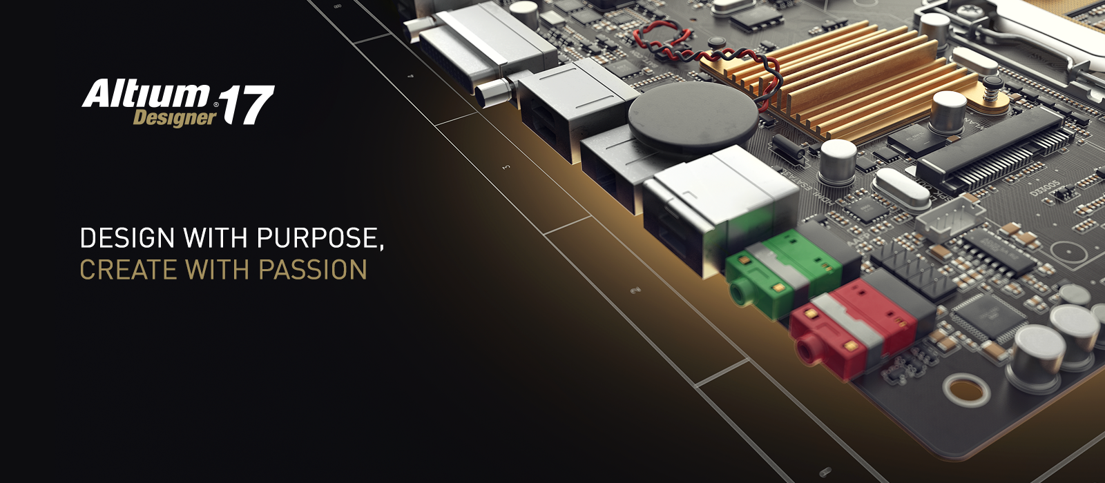
Picture available: info@prismapr.com

Press Release 15/2016

Visit Altium at electronica 2016
in Hall A1, Stand 572

Altium Announces New Landmark PCB Design and Data Management Technologies Following Record User Growth

Altium LLC, the Global Provider of Innovative Electronic Design Solutions, Announces the Forthcoming Release of New Landmark PCB Design and Data Management Technologies in Altium Designer 17 and Altium Vault 3.0 Following Record User Growth in 2016.

San Diego, CA – Munich, electronica 2016, 2 November 2016 — In the midst of record user growth, Altium has announced the upcoming release of new landmark PCB design and data management technologies in Altium Designer 17 and Altium Vault 3.0. These new technologies will continue to drive the company’s goal of becoming the leader in PCB design software by 2020, with over 5000 engineers having already switched to Altium Designer in FY2016. Altium Designer 17 and Altium Vault 3.0 are both scheduled to release in November as a free upgrade to all Altium Subscription customers. Engineers can explore the new technologies on the Altium Designer 17 and Altium Vault 3.0 coming soon pages.

“We’ve reached new heights in our mission to supply modern designers with the tools they need to succeed, hitting a record $100 million in sales this past year,” said Henry Potts, Chief Operating Officer at Altium. “Our continued growth allows us to consistently deliver leadership technology in design automation software as we advance toward our goal of becoming the worldwide market leader of PCB ECAD solutions.”

Reach the Peak of Your Engineering Efficiency
The upcoming release of Altium Designer 17 features impressive technology geared toward strengthening the efficiency of today’s electronics design process. Designers can reach the peak of their engineering potential with several new features, including:

- ActiveRoute™ which allows an engineer to design high quality Printed Circuit Board layouts with high-performance, guided routing technology.
- Dynamic Copper which allows engineers to save time with the ability to easily modify copper polygon shapes on Printed Circuit Boards.
- Back Drilling which allows engineers to reduce signal integrity disturbances on high-speed designs with complete control over drill hole specifications.

To explore more new features in the upcoming release, visit the Altium Designer Coming Soon page.

“PCB designers continue to be confronted with time consuming interactive routing challenges,” said Charles Pfeil, Senior Product Manager at Altium. “With ActiveRoute™, we’ve pushed routing technology into a new frontier by providing complete user control and flexibility for high quality routing in a small fraction of the time.”

Connecting Engineering Efficiencies
With the upcoming release of Altium Vault 3.0, engineers can leverage new technologies to gain more control over their data management workflow, with new ways to search, synchronize and manage their design data using the following features:

- Streamlined Project Releaser which enables an engineer to easily add verified project snapshots with included design variants for fabrication and assembly.
- Customized Item Manager Automatching which allows engineers to quickly synchronize projects and define parameters to update unmanaged assets with verified design data.
- Expanded Templates which allows engineers to keep their design projects standardized with templates for Projects, Draftsman®, Scripts, and Bill of Materials reports.

To explore more new features in the upcoming release, visit the Altium Vault What’s Coming Soon page.

Availability Details
The wide selection of new technologies being introduced in Altium Designer 17 and Altium Vault 3.0 will be available this November as free upgrades for existing Altium Subscription customers on the Altium Downloads page. Customers not currently on Altium Subscription can contact Altium Sales to upgrade.

To attend a webinar on the upcoming features in Altium Designer 17, register here. To attend the webinar for Altium Vault 3.0, register here.

Contacts:

Waldemar Stein
Altium Europe GmbH
+49 721 8244 110
waldemar.stein@altium.com

Joseph Rigoli
LEWIS
+1 781 418 2423
arena@teamlewis.com

Gabriele Amelunxen
PRismaPR
+49 8106 247 233
info@prismapr.com

Monika Cunnington
PRismaPR (UK, Scandinavia & Benelux)
+44 20 8133 6148
monika@prismapr.com
www.prismapr.com

About Altium
Altium Limited (ASX: ALU) is a multinational software corporation headquartered in San Diego, California, that focuses on electronics design systems for 3D PCB design and embedded system development. Altium products are found everywhere from world leading electronic design teams to the grassroots electronic design community.

With a unique range of technologies Altium helps organisations and design communities to innovate, collaborate and create connected products while remaining on-time and on-budget. Products provided are Altium Designer®, Altium Vault®, CircuitStudio®, PCBWorks®, CircuitMaker®, Octopart®, Ciiva® and the TASKING® range of embedded software compilers.

Founded in 1985, Altium has offices worldwide, with US locations in San Diego, Boston and New York City, European locations in Munich, Karlsruhe, Amersfoort, Markelo, Kiev and Zug and Asia-Pacific locations in Shanghai, Tokyo and Sydney. For more information, visit www.altium.com. You can also follow and engage with Altium via Facebook, Twitter and YouTube.

