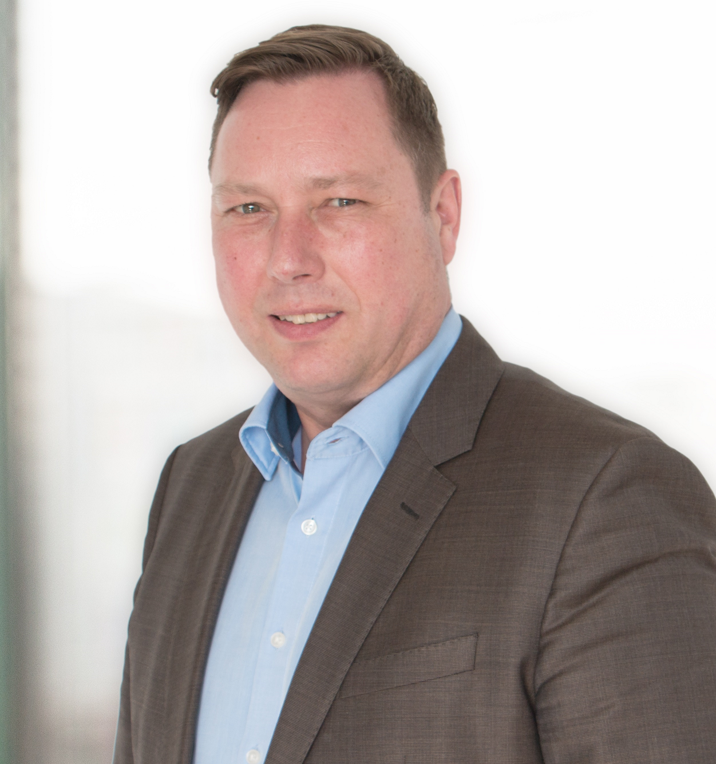

Photo of Rainer Asfalg available: info@prismapr.com

Press Release 14/2016
Visit Altium at electronica 2016
in Hall A1, Stand 572

Rapid Growth at Altium Limited Leads to New EMEA Locations – Munich now New European Headquarter

Munich (Germany), – 27 October, 2016 – Altium Limited, a global leader in smart system design automation, native 3D PCB design (Altium Designer) and embedded software (TASKING), has expanded its presence in the EMEA region by opening a new office in Munich.

Since 2002, the European headquarter of Altium Europe GmbH has been located in Karlsruhe. Due to positive market development in recent years and the expansion of the company’s business activities, the European headquarter relocated to the new Munich office in September 2016.

As one of the most important economic hubs in Europe, Munich provides excellent infrastructure and connectivity, accompanied by a high density of high-technology companies, resulting in ideal conditions for the pan-European section of the global company. This equally applies to the maintenance of the existing customer base and new customer business activities.

“Leading industries increasingly adopt our product lines,” said Rainer Asfalg, Vice President Sales EMEA. “Following a very successful fiscal year and the opening of an additional branch office in the Netherlands, it was a logical step to strengthen our position in our core markets.”

In his role as vice president sales EMEA, Rainer Asfalg is responsible for the European headquarter. In addition to the sales department, his teams in Karlsruhe, Munich and Markelo (Netherlands) take care of the pre-sales support and sales operations for the Altium Designer and TASKING product segments. The Karlsruhe office additionally provides post-sales support (hotline, training and consulting), which enjoys great customer acceptance. Altium will increase its Munich staff count for this sector as well.

Contacts:

Waldemar Stein
Altium Europe GmbH
+49 721 8244 110
waldemar.stein@altium.com

Gabriele Amelunxen
PRismaPR
+49 8106 247 233
info@prismapr.com

Monika Cunnington
PRismaPR (UK, Scandinavia & Benelux)
+44 20 8133 6148
monika@prismapr.com
www.prismapr.com

About Altium
Altium Limited (ASX: ALU) is a multinational software corporation headquartered in San Diego, California, that focuses on electronics design systems for 3D PCB design and embedded system development. Altium products are found everywhere, from world leading electronic design teams to the grassroots electronic design community. With a unique range of technologies, Altium helps organizations and design communities innovate, collaborate and create connected products while remaining on time and on budget.

Products provided are Altium Designer®, Altium Vault®, CircuitStudio®, CircuitMaker®, Octopart®, Ciiva® and the TASKING® range of embedded software compilers.

Founded in 1985, Altium has offices worldwide, with US locations in San Diego, Boston and New York City, European locations in Karlsruhe, Munich, Markelo, Amersfoort, Kiev and Zug and Asia Pacific locations in Shanghai, Tokyo and Sydney. For more information, visit www.altium.com. You can also follow and engage with Altium via Facebook, Twitter and YouTube.

